Exam 1
Basic lecture outline
Check page breaks before printing
Fill in the missing material in class

Biology 102
General Biology

rev. 7/21/20

O. About the Course
A. Introduction
1. about me
B. Labs are a separate course: 04-103
1. Labs begin next week
2. buy the 04 103 lab manual in the BOOKSTORE in the Union:
3. read Lab 1 before lab (Cells)
4. visit the lab (04-103) website on Northwest Online
a. “Safety Quiz”
b. “Contract”
c. before the first lab
C. Course Syllabus: Read it. You are expected to understand it.
1. office hours
2. schedule
3. policies
D. Textbook: fish eye on cover
1. not needed in lecture
2. chapters listed on syllabus
3. read, lecture, reread, especially illustrations
E. Exams & grades
1. all multiple choice
2. NOT all regurgitation, some from text
3. four exams over recent material, 50 questions for 100 points
4. final exam week: both exams at our scheduled time
a. Exam 4 (not cumulative)
b. Exam 5 (tests student ability to apply knowledge)
5. grades will be posted on Northwest Online, announced by email
F. Course points
1. course total is 458 points
2. each of first 4 exams is 100 points (50 questions)
3. fifth exam is 40 points
4. extra credit
a. several opinion-type surveys, online and anonymous
b. attendance
5. course grade: 412 points for an A (90%), 366 for a B (80%), etc.
G. Lecture
1. seat assignments
2. questions welcome
3. planning to record them and posted online
4. outline format: listen and write
5. I do NOT provide copies of the projected notes
H. Study help
1. Course Northwest Online website
a. lecture outline: stripped down
b. study hints
2. Student Success Center
a. Owens Library second floor
b. free but by appointment
c. many kinds of help!
3. Weekly Tutoring Group (SI sessions)
a. focused collaborative learning
b. SI? to be announced
4. study groups: compare notes, quiz each other, etc.
5. write your own sample exam
a. 3-4 questions per page of lecture notes
b. write after each lecture, set aside until studying
c. don’t forget questions that span multiple lectures
4. sample exams
a. posted online
b. answers will be available just before exam
c. use after studying, to find weak areas
I. Course expectations
1. attend and keep up
2. this is NOT high school
3. there is NO study guide
I. Describing Life

A. Characteristics of life
1.
2.
3.
a. crystals just accrete
b.
4. grow and develop:
5. respond to stimuli
a.
b.
6. have adaptations
7.
a. distinct from environment
b.
c. humans: maintenance uses about 1600 cal/day
(about 75% of recommended caloric intake)

B. Sorting life
1. size scale:

2.
a. Linnaeus (1750s)
1)
2) species (sp. or spp.) indicated by two latinized words:
genus (capitalized, italicized), species (italicized).
3) e.g. Canis familiaris = domestic dog
b. Biological Species Concept
1)

2) e.g. horse & donkey --> mule (sterile)
c. basic taxonomic units
species, genus, family, order, class, phylum, kingdom, domain
d. examples
Common name | Species | Genus | Family | Order
dog | C. familiaris |  |  | Carnivora
timber wolf | C. lupus |  |  | Carnivora
hyaena | H. hyaena |  |  | Carnivora
house cat | F. sylvestris |  |  | Carnivora
mountain lion | F. concolor |  |  | Carnivora
humans | H. sapiens |  |  | Primates

e. complications
1) animal kingdom uses the word "phylum"
a) others
b) Animals: king phillip came over for green spaghetti
2) finer divisions are available: sub- and super-
e.g. suborder, order, superorder, subclass, class
II. Cells

A. Membranes
1. structure
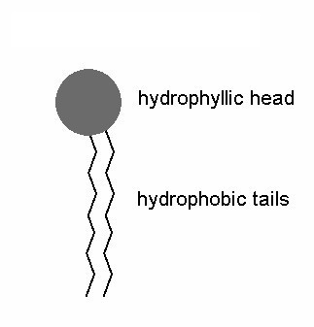
a. phospholipid
1)
2)
3) phospholipids in water:
c. biological membranes
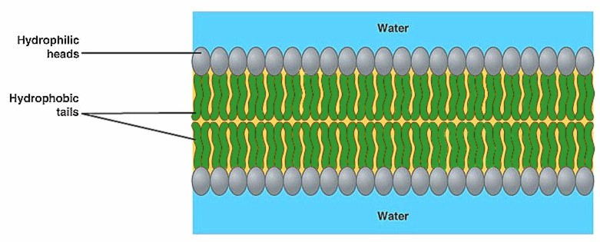
1) bilayers

2)
3) proteins floating in layer of liqued:
a)
b) proteins can be on the inside, the outside, or both
c) some proteins form channels
2. functions
a.
b.
c.
3. crossing membranes
a.
1) water passes without any problem
2)
not even H+
3) uncharged particles cannot pass the heads
b.
1) via
2) follows gradient, two-way transport, no energy used
3)
4)
5) like a revolving door
c. active transport
1) uses
2)
3)
4)

B. Enzymes
1. are reaction facilitators
a.
b.
c.
d. many are named for what they do:
e.g. lactase, dehydrogenase, synthetases, proteases
2. structure
a. mostly protein
1) primary structure:
2) secondary:
3) tertiary
a)
b)
b. cofactor
1) helps
2) many trace elements (Fe, Mg, Mn)
3. activity
a. terms
1) substrates:
2) products:
b.
1) is a pocket on the enzyme surface that
2) is part of the tertiary structure (3d shape)
3)
c. enzyme action
1)
2)
3)
4) then the products are released
5) enzyme returns to original shape
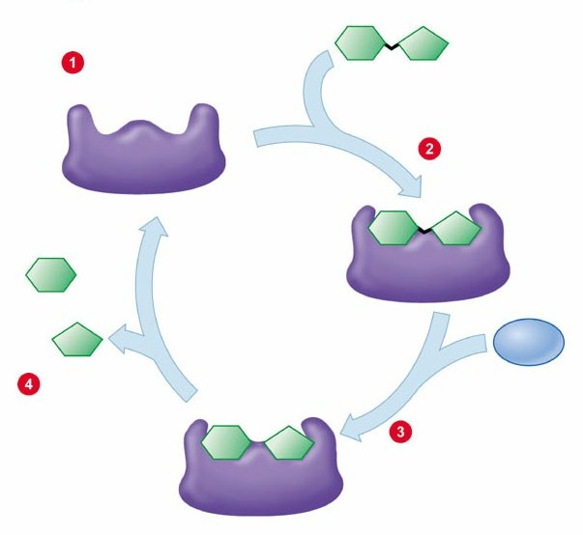

6) e.g. cytochrome-c:
a) arrival of electrons
b) oxygen (O₂) binds
c) new active sites open for two H+
d)
d. key to function is the
1)
2)
e. poisons
1) resemble normal substrate, so they can occupy site
2)

C. Organelles
1. nucleus
a. double membrane
b. nucleoli
c. contains
d. main role is
2. ribosomes
a. made of ribosomal RNA ( = rRNA)
b.
3. endoplasmic reticulum (ER)
a.
b.
c. smooth ER forms channels
d. rough ER
1) has
2)
3)
4. golgi bodies: packaging factory
a. formed by fusion of vesicles
b. are membrane-bound sacs which
c. break up into vesicles
5. mitochondria
a. convert energy (NADH to ATP)
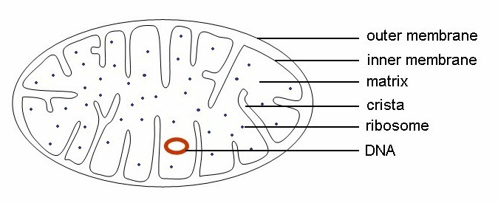
b.
c. cristae, matrix

6. chloroplasts
a. convert sunlight into sugars (photosynthesis)
b.

c. thylakoids, grana, stroma
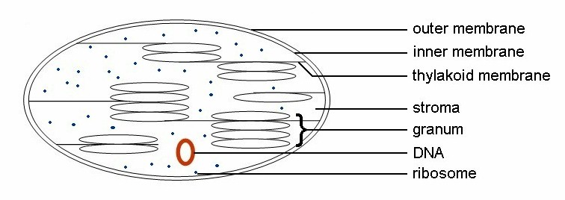

d. Endosymbiotic Theory
1) mitochondria and chloroplasts are descended from

2)
3)
7. cytoskeleton (fibers)
a. microfilaments
b. microtubules
8. vacuoles
a. storage
b.
c. may be
9. lysosomes
a.
b. e.g. digestive enzymes, poisons
10. cell wall
a. inert
b. mainly cellulose
III. Life Chemistry

A. Elements
1. universe is made of atoms: any material can be broken down
into some combination of
2. regions of the atom
a. nucleus
1)
2)
3) determines how many electrons can be held
b. orbitals
1)
2)
3) determine atom's behavior with others
c. size determines how the element behaves
c. size determines how the element behaves
d. symbols to know

H hydrogen C carbon N nitrogen O oxygen
Na sodium Si silicon P phosphorus S sulfur
Cl chlorine K potassium Ca calcium Fe iron

3. biologically critical elements
a. oxygen
1) 65% of living body's mass (mostly water)
2) molecule O₂ is important
b. carbon
1)
2) can bind up to
3) vastly important in life chemistry and structure
c. hydrogen
1)
2) one proton and one electron
3) in many molecules in life, esp. water, proteins, fats
4) chemically, is pH (low pH = many free H+ ions = acidic)
d. nitrogen
1)
2)
e. phosphorus
1)
2) important in forming high-energy bonds
f. sulfur
1)
2)
4. other elements
a. trace elements: needed by most species
1) mostly as
2)
3) e.g. Ca, Cl, I, Fe, Mg, K, Na, Zn
b. needed by some species
1) about 30 elements
2) esp. Si, Al, Ni, As, Be
c. remaining elements
1)
2)
3) e.g. U, Th, Kr

B. Chemical bonds:
1. covalent bonds:
a. strong bonds;
b.
2. ionic bonds:
a. in solution, one atom has a stronger attraction to outer
electron(s), so it pulls it (them) away
b. e.g. in salt (NaCl)
3. hydrogen bonds: weak, but important in water

C. Water
1. is polar:
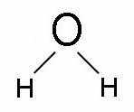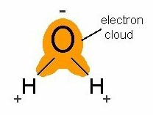

2. has hydrogen bonds
a. water has temporary clumps and strings of H₂O in it
b. makes water
3. is the "universal solvent":

4. interactions of water and molecules
a.
1)
2) tend to be insoluble: fats, oils, nonpolars
3)
b.
1)
2) tend to be soluble: ions (salt), polar molecules
5. diffusion: molecules in solution
a. example: dye in fishtank spreads out evenly,
b. cause
1) random movement of molecules
2) some molecules near edge of dye will move out of patch,
some in
3)
c. is molecule-specific: direction depends on the

d. more examples: sugar solutions
1) u-tube with no barrier
2) u-tube with semi-permeable membrane
3) u-tube with membrane and weight
e. factors in diffusion
1)
2)
3)
4)
f. concentration terms
1) hypertonic:
2) hypotonic:
3) isotonic:
4) osmosis:

D. Organic molecules
1. carbohydrates
a. sugars & combinations of sugar molecules
b. general formula:
c. store energy as
d. types of carbohydrates
1) simple sugars
a)
b) usually 5 or 6 Cs, often rings
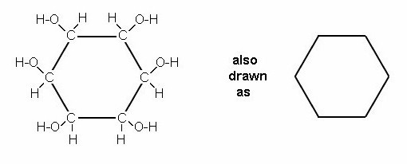

c) some from photosynthesis. e.g. glucose
2) polysaccharides (polymers): chains of rings
a)
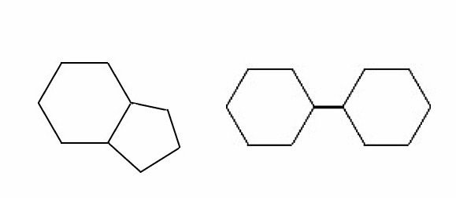
(1)
(2) e.g. sucrose
b)
(1)
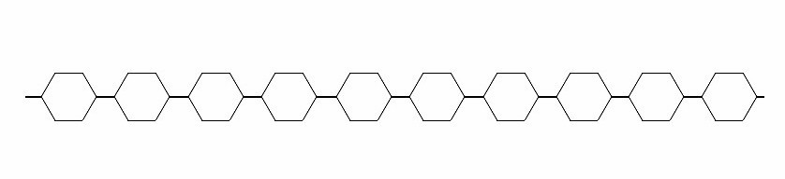

(2) e.g. chitin and cellulose
c)
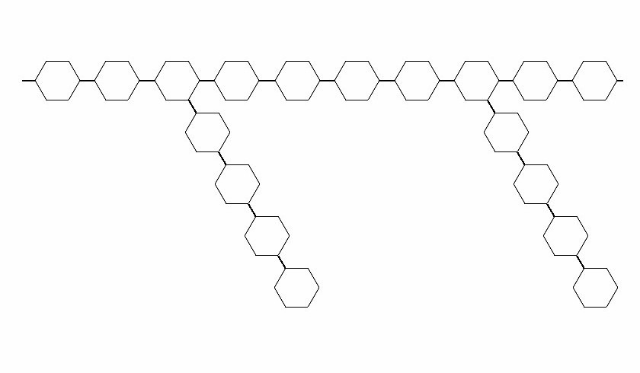
(1)
(2) e.g. starch and glycogen
2. proteins
a. are polypeptides: chains of
b. only 22 amino acids known
c. common structure of aa's:
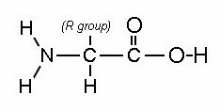

1) one peptide is

2)
a) in glycine,
b) in alanine,
3) R can have a
d. protiens are polypeptides
1) chains of amino acids ( = chains of peptides)
2) formed by ribosomes by
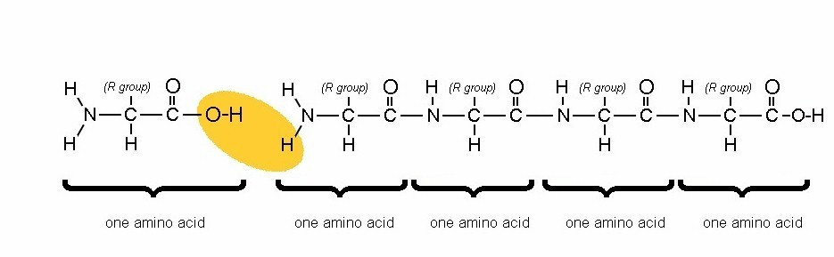

e. proteins automatically

3. nucleic acids: DNA, RNA
a. RNA = ribonucleic acid
1) chain of
a)
b)
c)
Uracil, Guanine, Cytosine, Adenine in RNA
2) structure:
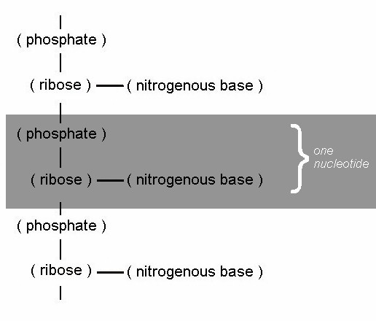

b. DNA = deoxyribonucleic acid. Like RNA, but
1) the sugar has one less
2) the molecule is
3) uses
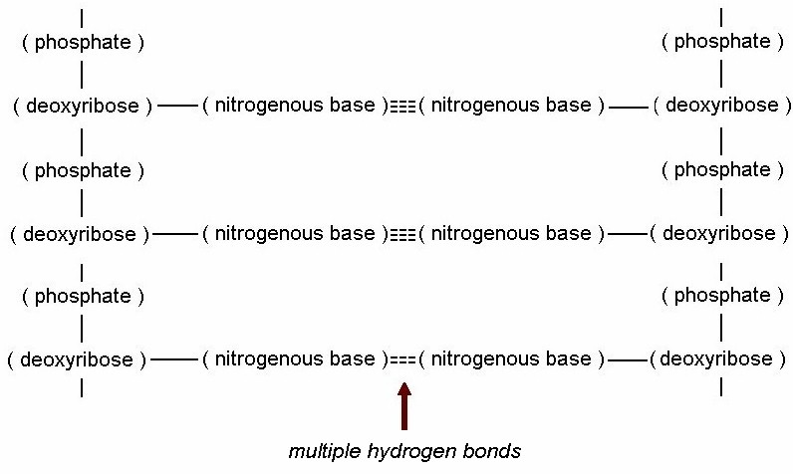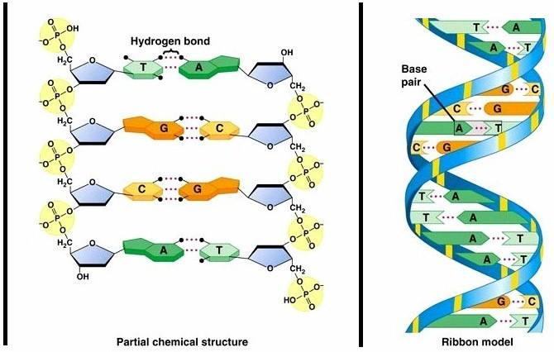

4. lipids
a.
b.
c.
d. fatty acids

1)
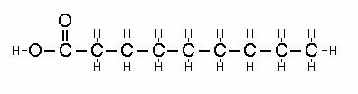

a)
b) fats; solid; clog arteries
2)
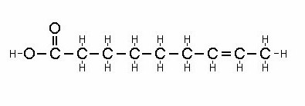

a)
b) oils; liquid
e. triglycerides: fats, oils, waxes
1) a glycerol

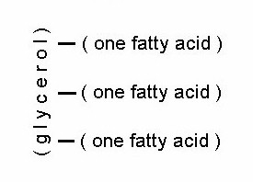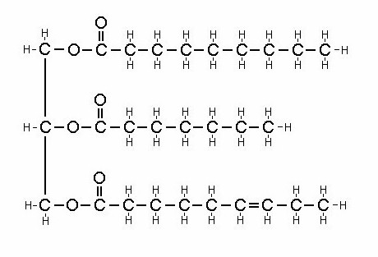

f. phospholipids
1) structure
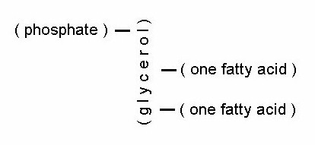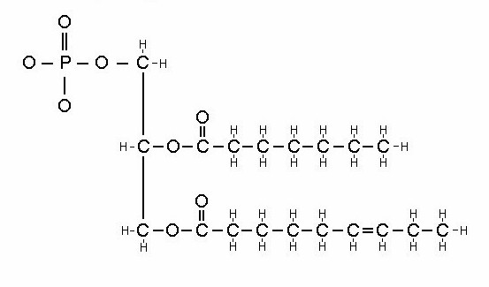

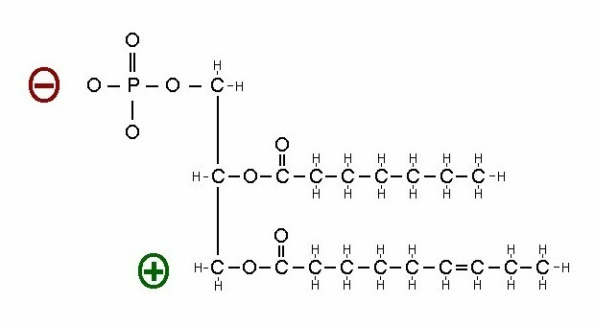

2) head is
(PO₄ is slightly negative, C's are slightly positive)
3) tails are
4) also drawn as
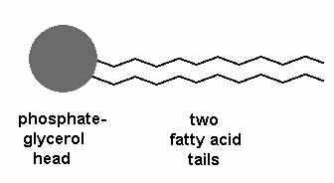

IV. Energy

A. Energy molecules
1. short term:
a.
b. like nickels, dimes, quarters
c. types

High-energy version | Low-energy version | Role
ATP
NADPH
NADH
FADH

d. ATP = adenosine triphosphate
1) like an aa with
2) energy
2. medium term:
a.
b. like $10 bills
c.
3. longer term:
a.
b. like $100 bills
4. longest term:
a.
b. like savings account

B. Cell respiration: release of energy from sugars
1. glycolysis
a.
b.
c. reaction

d.
e.
f. problem
1) requires NAD, but this is rare in cells
2)
2. fermentation
a. one way to recycle NAD so glycolysis can continue
b.
c. in animals (e.g. hard-working muscles):

d. in all others (for example, yeast):
e. brewing
1)
2)
3)
4)

f. fermentation is

3. prep step: beginning of 2nd way to recycle NAD
a.
b.
c. reaction:

4. Krebs cycle
a.
b.
c.
d. reaction:

d. Krebs energy summary

5. oxidative phosphorylation
a.
NADH NAD
ADP & P → ATP
oxygen (O₂) H₂O (water)

and also

FADH FAD
ADP & P → ATP
oxygen (O₂) H₂O (water)

b.
c. last enzyme is cytochrome-c
d. breaks O₂, adds electrons and H+

C. Respiration summary

C₆H₁₂O₆ CO₂
ADP & P ATP
O₂ H₂O

C₆H₁₂O₆ CO₂
ADP & P ATP
O₂ H₂O

C₆H₁₂O₆ CO₂
ADP & P ATP
O₂ H₂O

C₆H₁₂O₆ CO₂
ADP & P ATP
O₂ H₂O

D. Substrates & Products

Reaction | Substrate | Products
Glycolysis
Fermentation (animal)
Fermentation (others)
Prep step
K Krebs cycle
Oxidative phosphorylation

E. These reactions form one big mega-reaction

sugar

glycolysis

pyruvate & ATP

OR

fermentation prep step

acetyl CoA, NADH, CO₂
in animals: NAD & lactate
or in plants: NAD, CO₂, ethanol Krebs cycle

NADH, FADH, & ATP

oxidative phosphor.

NAD, FAD, & ATP

end of Exam 1 material

